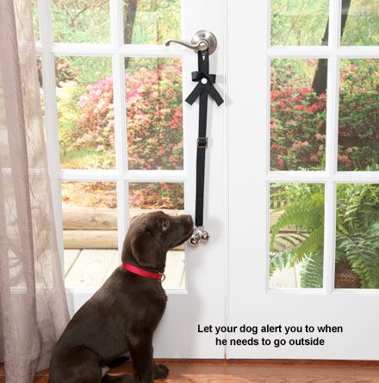

Bell Training
Bell training can be an effective way to train dogs to give you a signal that they need to go out to potty! Some dogs catch on quickly, others take some time. But all dogs can do this! First step is to purchase potty bells (available on line or at any pet store). I suggest hanging the bells on the door knob or next to the door (so the bells aren’t ringing every time someone goes in or out). But, either way is fine.
- First, show the bells to your dog by holding them. If they sniff them, nudge them or touch in any way, praise (i.e. “yes!” or “good girl/boy!”) and treat! If they won’t touch them, you can even start off with rewarding for just looking and then build up to touching them. If they are afraid of the bells, lay them on the ground or in your hand to stop them from ringing, smear a little peanut butter on them and see if they will sniff or lick them. If they do, praise and reward them. Once they are touching them easily, add the cue “touch bell.” Then, try holding them upright but scrunch them up and gradually work on letting them out to the full length as they are touching them using the “touch bell” cue. Reward with a treat or hard kibble (dog food) each time they touch it. Once they are touching on cue with you holding them up, fully extended, start moving towards the door you will hang them on. Then hang on the door (or wall) and practice having them touch the bells. Once they are ok touching them, you are ready to begin.
- Any time your dog goes out to potty, go to the door, say your cue word (i.e. “lets go potty”), point to the bell and say “touch bell”. As soon as they do, praise and open the door. If you are in a rush to get them out as to avoid an accident, then you ring the bell and take them out. If they potty outside, reward them on the spot (not when you come back in).
- Do this every time.
- If you are going to play outside or go for a walk after your potty break, reenter the house and exit again without ringing the bell. We want your dog to learn that ringing the bell is just for potty time.
- At some point, your dog will touch / ring the bell out of curiosity. When this happens, stop everything you are doing and rush them outside following your same potty protocol.
- Over time, your dog will learn to alert you to go out and potty by ringing the bell. And the great thing is that you can take the bell with you if you are traveling or visiting someone’s house.
- Note that once your dog learns to ring the bell, they will figure out it gets them outside. So they will ring it to try and get out. If you are sure they don’t need to potty, simply redirect them to do something else. Otherwise, let them out.

